**INFERENCES**

Inference 1:

BIOGRAPHY

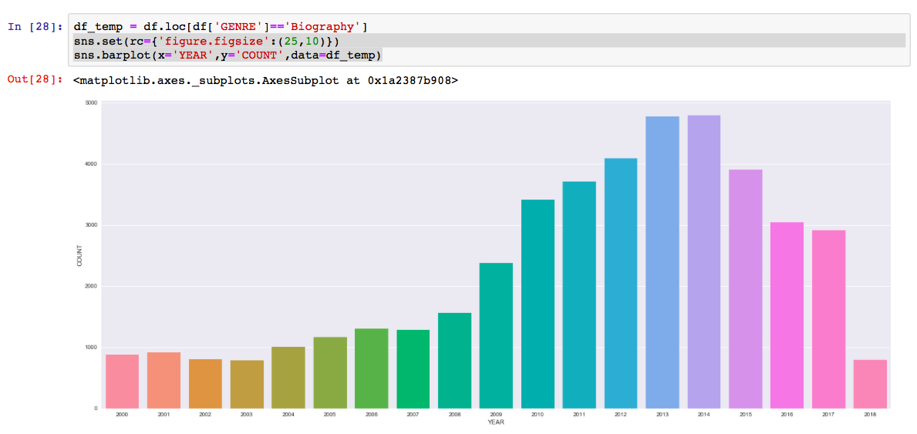

Sudden increase in production of biography genre in 2009 and 2010 with peaks reaching 2013 and 2014. Movies like the Blind Side, Public Enemies, Social Network, 127 HOURS, etc. were very successful at the box office which led the producers to think that movies based on biographies were the way to go but, this genre reached its saturation in the year 2013 and

2014 after which there is sudden drop in production of these movies.

Inference 2:

COMEDY

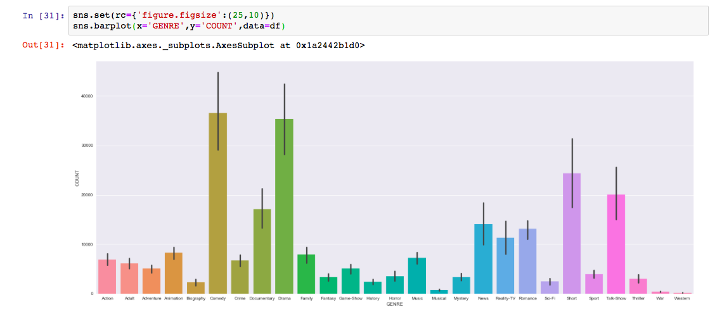

COMEDY movies have the highest count having upward of 35000 movies produced from 2000 to 2018 and the second being drama which has a count of approximately 35000 movies in the same period. The reason for this count is that comedy and drama are genre which take less time and budget to produce compared to other genres.

Inference 3:

CRIME

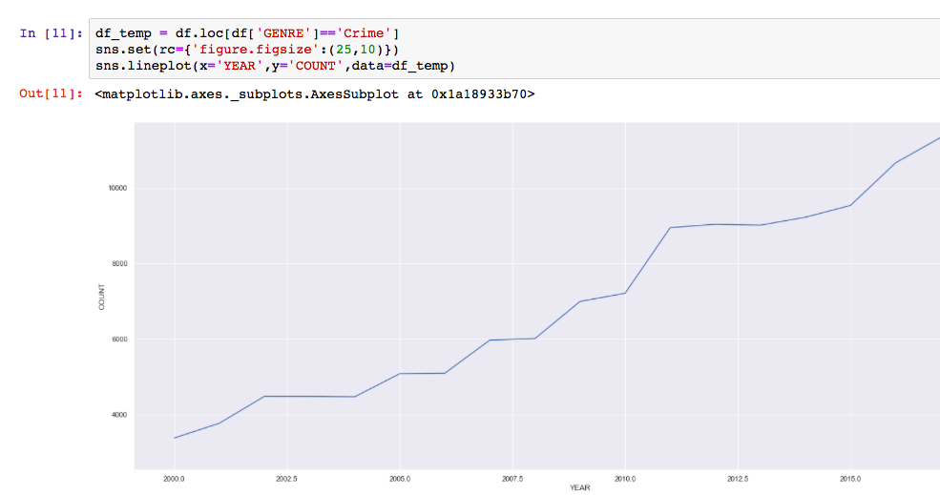

Over the years we are observing that CRIME genre is increasing and it is the only genre where there is no significant decrease. We see this pattern because people are becoming more self aware about their surrounding. We see it peaking in 2017 with over 15000.

Inference 4:

WESTERN

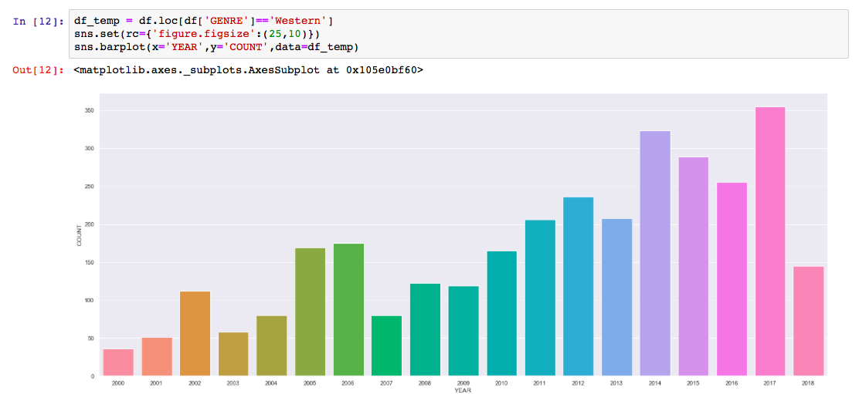

Compared to all other genres western has the least maximum the reason behind this is western appeals only to a small subset of people and hence less movies are produced and that’s the reason why western doesn’t have a pattern.

Inference 5:

ROMANCE

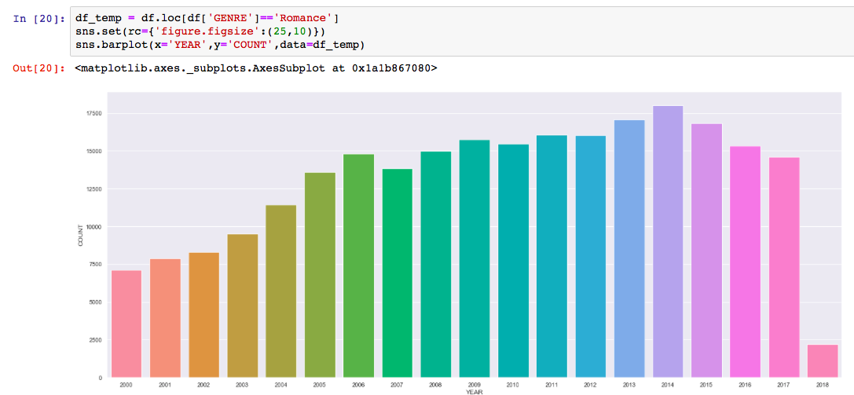

Romance is a genre which doesn’t have significant drops or raise especially in 2004 to 2017 because it is a very beloved genre which attracts masses that’s why there is no trend in this genre.